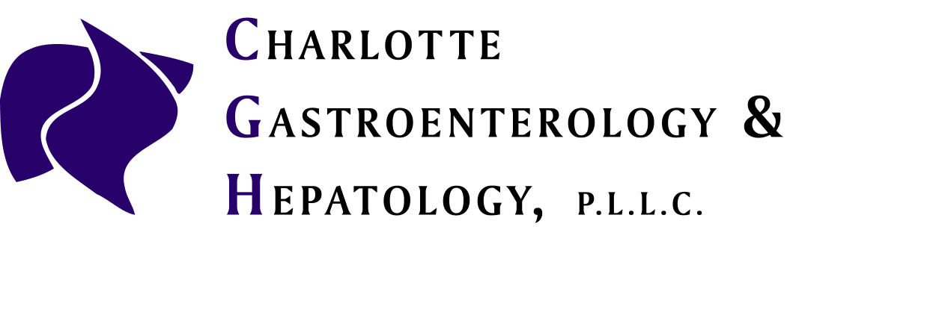

TWO DAY CLEAR LIQUID PREP
Recommended Days To
MEDICATION Stop Prior to Procedure
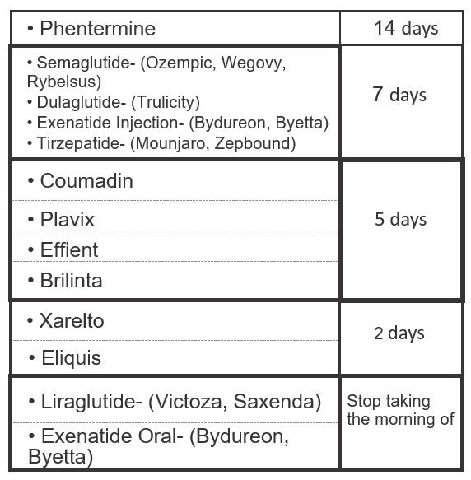

Two days prior to procedures: Upon awakening, no solid food. Clear liquid diet only. To include: broth, jello (no red or purple), coffee or tea (sweetener is ok, but no milk), popsicles, juices that are clear and pulp free.

At 6 PM: Drink (1) 10oz bottle of Magnesium Citrate

Continue clear liquid diet.

Day before procedure: Continue clear liquid diet. Follow prep instructions on prep sheet given to you.

